Joel Baby
Module 8.2 Assignment

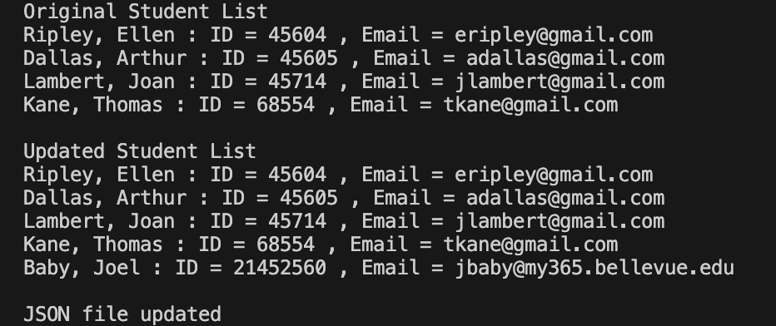
Pop up didn’t show up on the newest version of vs code in macOS.
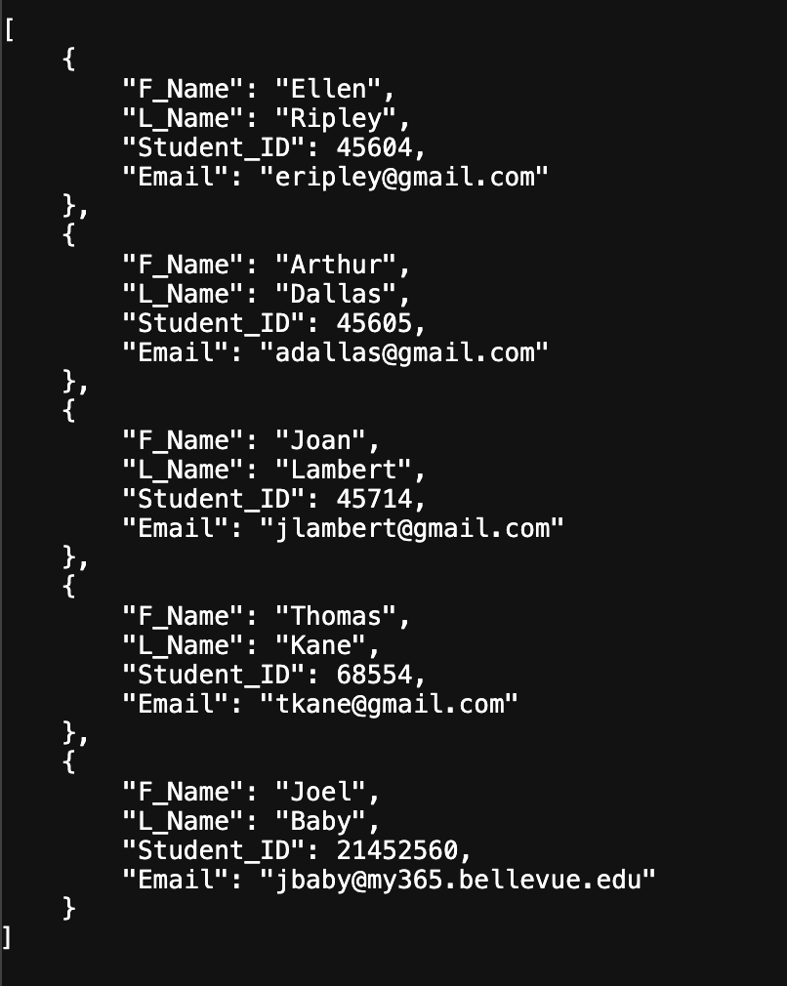
[
{
"F_Name": "Ellen",
"L_Name": "Ripley",
"Student_ID": 45604,
"Email": "eripley@gmail.com"
},
{
"F_Name": "Arthur",
"L_Name": "Dallas",
"Student_ID": 45605,
"Email": "adallas@gmail.com"
},
{
"F_Name": "Joan",
"L_Name": "Lambert",
"Student_ID": 45714,
"Email": "jlambert@gmail.com"
},
{
"F_Name": "Thomas",
"L_Name": "Kane",
"Student_ID": 68554,
"Email": "tkane@gmail.com"
},
{
"F_Name": "Joel",
"L_Name": "Baby",
"Student_ID": 21452560,
"Email": "jbaby@my365.bellevue.edu"
}
]

